DO YOU WANT TO TRAVEL ABROAD?
STRUGGLING TO FIND THE CASH?
AVS HAVE THE SOLUTION!
AVS have introduced TWO brand new travel grants worth £250 each for conferences outside the UK!!!
Deadline: 28th February 2018
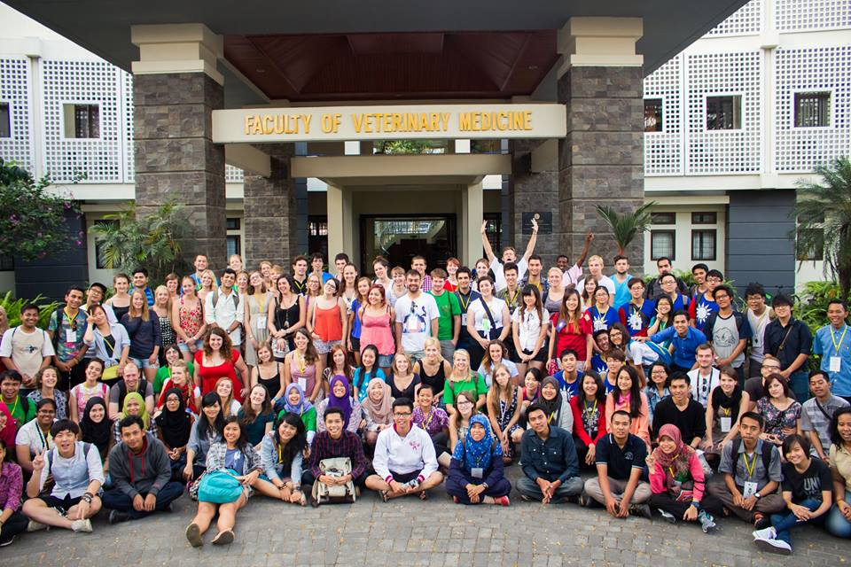
IVSA Conference in Indonesia (2014)
This could be you at the next IVSA conference in 2018!
Apply by visiting www.avsukireland.co.uk
(Travel Grants on Opportunities Page)

