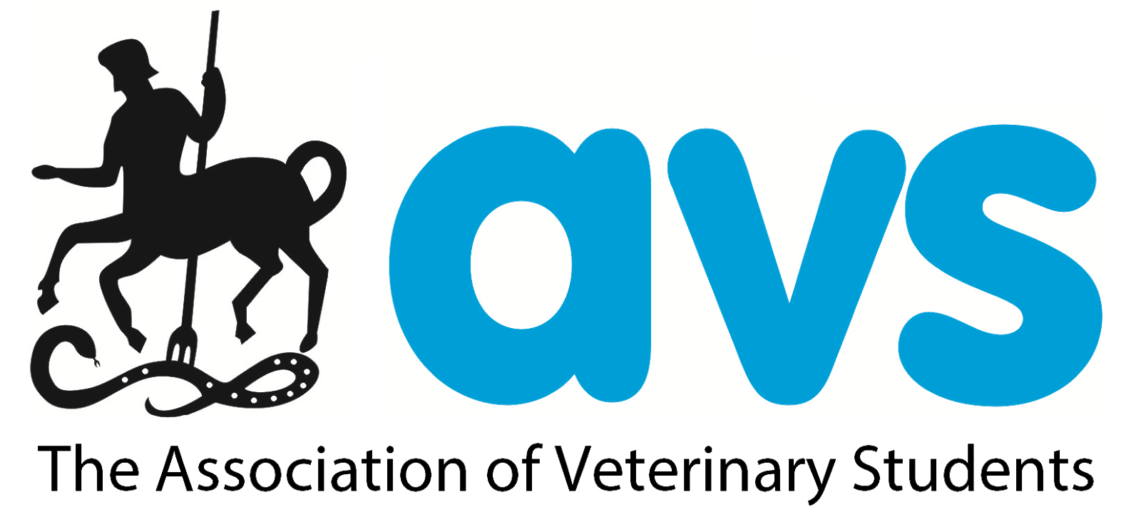

The Association of Veterinary Students
Extra Mural Studies (EMS) Experience Survey

Results 2018

Contents:

Section 1: AVS President’s Introduction 2

Section 2: Target Audience & Respondents 5

Section 3: Graduates’ Experiences of Extra Mural Studies (EMS) 7
3.1 Respondents
3.2 Graduates’ Experiences of EMS
3.3 Employment Connections Between Graduates and their EMS Practices

Section 4: Bristol Students’ Experiences of The EMS Foster Practice System 9
4.1 Overview of The Foster Practice System
4.2 Foster Practice System Uptake Rates
4.3 Benefits of The Foster Practice System
4.4 Foster System in Practice
4.5 Negative experiences of The Foster Practice System

Section 5: Students’ Experience of Clinical Extra Mural Studies Placements 13
5.1 Top Priorities for Clinical EMS Placements
5.2 Clinical EMS Experiences

Section 6: Pre-Clinical Students’ Expectations of Clinical Extra Mural Studies 16
6.1 Respondents
6.2 Concerns about Clinical EMS
6.3 Opinions on why Clinical EMS is useful

Appendix I: The AVS Extra Mural Studies Experience Survey 2018 Questions 18

AVS President’s Introduction

The Association of Veterinary Students (UK & Ireland) is the representative body for all veterinary students studying within the UK & Ireland. AVS committee represent our members on issues which concern them, produce resources and share advice on a group level to support our members.

One of AVS’ priority areas for 2018/19 was Student Experiences on Extra Mural Studies
(EMS). AVS have entered into a partnership with the Veterinary Defence Society (VDS
Training) to provide AVS’ Inaugural EMS Grants to help students with the financial burden of EMS, something which has been reported on widely, and as a result was not a core element researched in the EMS Experience Survey. These grants will open for application for the first time in Autumn 2018 and be awarded at AVS Congress 2019.

The second part of AVS’ EMS Experience project was to launch the first AVS EMS Experience Survey, and produce additional resources for practices as a result of this, to help optimise the value of EMS placements for students. The results of the survey and AVS’ new EMS resources will be launched in the first ever student led session at London Vet Show 2018 on the 16th November 2018.

Further information about The Association of Veterinary Students can be found at www.avsukireland.co.uk

Research aims and methods:

The survey was commissioned to allow AVS to seek student opinions on their EMS experiences to date. Students frequently voice concerns about the variability in quality of EMS and the distructure once students head out into practices on EMS. AVS also felt it would be valuable to survey some recent graduates to understand more about how EMS prepared students for working in practice as a new graduate, and to assess the link between EMS placements and first job opportunities. This career link is often alluded to and is occasionally used as an incentive for practices taking on EMS students.

The majority of previous EMS research has been centred around the costs student face in undertaking EMS during their holidays and the socio-economic restrictions students can face in acquiring EMS. As this has been analysed elsewhere by AVS and other organisations, it was not the primary aim of this survey.

This is the first time the survey has been conducted. The online survey was open for seven weeks during the final term of the 2017/18 academic year, and AVS received 1282 valid responses. This equates to 24% of AVS UK & Ireland’s membership which is approximately 96% of UK & Irish Veterinary Students. The high response rate is incredibly valuable to the integrity of the data collected and the analysis of it.

The questions were devised by AVS Policy Subcommittee and final approval was given by the AVS President as chair of the AVS Policy Subcommittee. The questions were broken down into three sections dependent upon the year group selected, these sections were;

- Recent graduate vets’ experiences of EMS & how EMS benefitted them in their first job
- Clinical vet students’ experiences of EMS and EMS aims (Years 3-5 + intercalated students who had undertaken Clinical EMS)
- Pre-clinical vet students’ awareness of clinical EMS and expectations of clinical EMS
(years 1-2 + intercalated students who had not yet started Clinical EMS)

Students who were categorised as clinical and attended Bristol were asked an additional set of questions regarding the Bristol Vet School “Foster Practice” system.

What is Extra Mural Studies (EMS)?

Completing Extra Mural Studies (EMS) is a requirement, stipulated by the Royal College of Veterinary Surgeons (RCVS), that all veterinary students studying in the UK & Ireland must meet prior to obtaining their degree and becoming an MRCVS. EMS is comprised of 12 weeks of Pre-Clinical EMS and 26 weeks of Clinical EMS (also referred to as seeing practice).

The RCVS states that: “EMS provides students with an unrivalled opportunity to gain real-life​ work experience that enhances their university-based studies.
Whilst the universities are responsible for teaching the skills that the student needs to practise when they first graduate (the 'day-one competences'), it is on EMS placements that students can further practise the animal-handling and clinical skills that they first learn at university, as well as build up their experience of dealing with clients and with members of the veterinary team.”
Each university has its own EMS coordinator and EMS administration team. In addition, universities set their own EMS placement suitability, recording and reflection criteria.
Most vet schools allow students to start clinical EMS from the third year of their degree, although it must be completed outside of university teaching time during the university holidays. As a result this has a substantial impact on veterinary students’ abilities to hold employment in their academic holidays. As a result of the financial costs (from travel, accommodation and catering requirements) and the loss of opportunities to gain income, many veterinary students undertake the majority of their clinical EMS at veterinary practices close to their parental or family home, something that in itself can limit the exposure to certain types of veterinary practice and subsequently limit career opportunities.
In 2014 The RCVS surveyed recent graduates regarding the value of EMS and this will also be used to input into the resources for practices that AVS produce.

David Charles
AVS President 2018/19

Target audience and respondents

The survey was conducted online and was open for seven weeks between 27/04/2018 and 18/06/2018. The survey link was circulated to current veterinary science students, including those on intercalated years, and recent graduates.

The survey was publicised via the following methods:
▪ AVS Facebook and Twitter pages
▪ Direct emails from AVS reps at every vet school to current students
▪ Direct emails from universities to current students, and from Glasgow University to their alumni
▪ Direct emails from Vets4Pets and IVC to current graduate scheme employees
▪ Direct emails to the AVS Alumni network
▪ Via VetSoc Facebook pages/groups, Twitter accounts and direct emails

5
The survey did not ask demographic questions , and therefore it is not possible to assess whether respondents are representative of either UK and Irish veterinary students, or the wider UK undergraduate population. It is also not possible to determine whether respondents from different backgrounds held similar or differing views. This should be particularly noted when considering students’ access to, and experiences of, EMS experience given students from particular social and geographical backgrounds may find it harder to source, and pay living costs to attend, a wide range of placements.

All Vet Schools were well represented in the respondent group, as demonstrated in Figure 1.

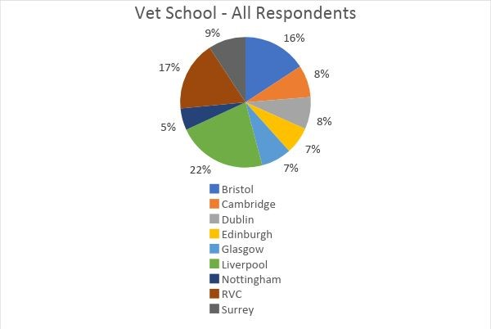

Figure 1: Respondents by Vet School

⁵ Relevant demographics include age, gender, disability, ethnicity, home region, caring responsibilities and socio-economic background, amongst others.

6
Respondents were predominantly current clinical (59%) and pre-clinical (35%) students.

Figure 2: Respondents by Year of Study
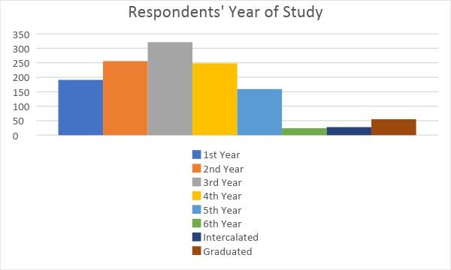

⁶ It is possible that a small number of students on six year courses selected ‘third year’ instead of ‘intercalated year’, due to the survey design. This would result in the number of clinical students being slightly overstated in the analysis.

Graduates’ experiences of EMS

Respondents

RVC had the highest number of graduate respondents (16), followed by Bristol and Liverpool (nine each).

Figure 3: Vet schools attended by graduate respondents
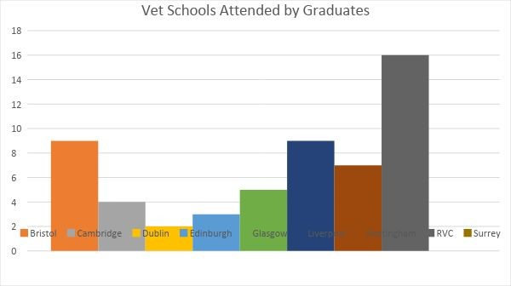

Graduates’ experiences of EMS

Respondents were highly positive about the ability of EMS to better prepare them for careers in practice than their degree rotations alone (96.7% agreed), demonstrating the essential nature of non-curricula experience.

The following features of EMS placements were highlighted by graduates as hallmarks of a beneficial placement:
▪ Enthusiastic, engaging and supportive staff to supervise students (vets and vet nurses).
▪ Planning the placement and setting goals with the student: providing a mentor, asking the student what they did and did not have experience of, and clearly explaining why the student could not be involved in certain procedures.
- 84% of respondents agreed that it would have been useful to have had an introductory chat and set placement objectives.
- This figure is similar to that for current clinical students (92.3%).
▪ Clinicians encouraging students to fully participate, as opposed to only observing – for example, assisting with surgeries, castrations, taking histories and disbudding.
- The majority of respondents felt their EMS placements gave them sufficient practical opportunities, although a number stated that this varied from placement to placement.
▪ Practices with varying caseloads.
▪ Supervising vets having sufficient time to teach and discuss cases between consults.
▪ Uncensored, realistic insights into the profession including paperwork, booking systems and high case volumes.

Employment connections between graduates and their EMS practices

Most graduate respondents (58.2%) received an offer from at least one of their EMS practices, demonstrating the strong connection between students and their placement practices as well as the benefits for practices seeking to recruit graduates of hosting EMS placements. Graduate recruitment is typically a resource-intensive and costly process for both employers and graduates, and recruiting EMS students can offer a simpler, less risky option for both parties.
Given this affinity, it is particularly important to ensure that all students have access to a diverse range of EMS placements to ensure students’ graduate opportunities are not constrained by their home region, socio-economic background or other diversity characteristics.

Figure 4: Prevalence of graduates applying for and working for a practice where they completed EMS placement

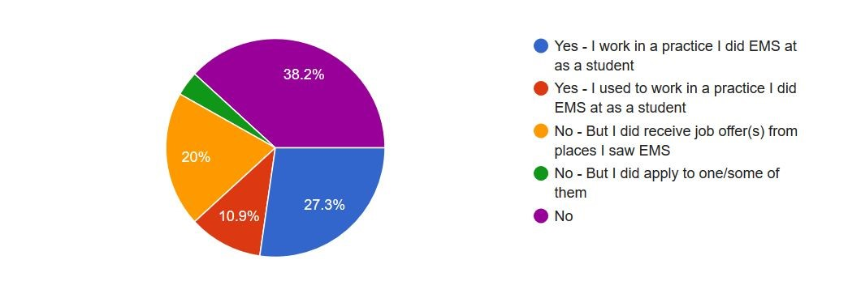

Bristol students’ experiences of the EMS Foster Practice System

Overview of the Foster Practice system
Note: On 20/08/2018, after the survey had closed and responses had been analysed, Bristol announced that students would no longer be required to find, and attend placements at, one foster practice. Students are now encouraged to visit multiple practices on a regular basis due to a significant decrease in the number of mixed practices in the UK.

Students at Bristol Vet School are encouraged to have a foster EMS practice which they return to over the course of their three clinical years (Years 3 - 5), completing between 10 and 14 weeks of clinical EMS with their foster practice. In the past Bristol advised students to find a mixed practice and see between 10 and 14 weeks there, however, now that there are notably fewer truly mixed practices, Bristol allow students to have a two species foster practice and spend approximately four weeks at a single species practice of the area not covered by their foster practice. Bristol state that:

‘This enables them to gain a continuous core of experience in a familiar practice environment…. Practitioners and students become familiar with each other, opening greater opportunities for the students to learn and to contribute to the practice… The aspect we find to be the most important, is that the student can build on experience over the three years in
7 each practice.”

Bristol students are encouraged to source a foster practice in second year and arrange a one or two day visit in second year summer prior to confirming a practice as their foster practice for years 3 - 5.

This section was only answered by current Bristol University vet students who had undertaken at least one clinical EMS placement.

Foster Practice uptake rates

75.6% of Bristol students stated that they had a Foster Practice, however, a number subsequently noted that they had sourced, or attempted to source, further experience from other practices due to poor experiences and/or narrow caseloads at their Foster Practice.

The most common reasons for respondents not having a Foster Practice were:
▪ Lack of access to suitable practices, primarily due to location. ▪ Inability to find a truly mixed practice.

⁷ https://www.rcvs.org.uk/document-library/ems-at-bristol/ems-bristol-15.pdf​
▪ Concerns over committing to one practice, only to find that they did not offer a good experience.
▪ Difficulty finding the ‘right’ practice, or a practice which would subscribe to the Foster Practice system.

10 respondents stated that location had prevented them from finding a Foster Practice. Comments included:

“0 mixed practices in my area, if I had funding I would be able to travel further and potentially have a placement.”

“Too many students per practice at home so I can't get a placement more than a couple of weeks at a time.”

It is likely that students requiring practices close to their home or university accommodation would be more affected by the relatively small number of mixed practices. Differences between practices and concerns over ‘fit’ are also likely to be experienced more frequently by students from particular backgrounds.

Benefits of the Foster Practice system
The majority of respondents (54%) had a more active role at their Foster Practice compared to other EMS placements, although 20% did not, and a further 16% did not have a Foster Practice or had not begun Foster Practice placements.

Similarly, respondents were generally positive about the Foster Practice system in principle, identifying key benefits including:
▪ Developing a deeper rapport and level of trust with the Practice’s staff and clients, resulting in the student being given more opportunities to lead activities (e.g. vaginal exams) and fully participate in clinical discussions.
▪ Avoiding the usual introductory period at the start of each placement (learning how the practice works, meeting new people, understanding the layout and typical caseloads, etc) which maximised productive placement time.
▪ Improving the chances of securing a graduate job at the practice.

Students with positive experiences often completed twelve to sixteen weeks with the same practice, built their skills and professional relationships and were trusted to perform surgeries by the end of their placements. For example, one respondent stated:

“I have spent 12 weeks in one practice, they have got to know me really well and I have felt part of the team. They give me more responsibility and allow me to get involved with more cases and procedures under supervision of the vets. I have now been offered a job at this practice as they know me very well and know I fit into the practice and get on well with the team.”

The Foster system in practice
Many respondents felt that finding a good Foster Practice was a good system in theory, but in practice is highly dependent on luck, the ability to try a few before committing to one practice, practices fully committing to the Foster system idea, and finding a genuinely mixed practice. A number of respondents felt that Bristol’s emphasis on the Foster Practice system increased students’ stress. For example, students commented that the system is:
“Potentially a good idea but only if you’re lucky to go to practices the first time that you want to return to and you get a lot out of.”
“Great in theory but need practices to be proactive. Maybe it would be better if they had to sign up with the uni to be a foster practice and then receive support from the uni for the students learning.”
“I have a small animal only foster practice and I think it puts unfair pressure on students to say that a foster practice should ideally be mixed, because there are fewer and fewer truly mixed practices and many students have a good idea of whether they want to go into mixed, small or farm practice by the time they choose a foster practice. I also think people need to be prepared to change fosters if they don't get on with their first practice - don't be afraid to "shop around" for somewhere you know you will be supported and be allowed to get involved!”
“I think it is a good system, although I think it should be more optional. I know Bristol don’t force it heavily on people that they have to have a foster practice as it can be challenging for some people but I think they should continue to say this as EMS can be stressful to organise without having the extra worry of finding a foster practice.”
The differential experiences and difficulty of finding mixed practices presents a risk that students without the resources (financial, networks or otherwise) to trial multiple practices and travel to a suitable placement could be disadvantaged against their more-privileged peers, leading to differential graduate outcomes.
One respondent emphasised the positive aspects of the Foster system, including the ability to gain confidence over a longer period of time, whilst also noting the potential downside to not seeing a diverse range of working environments:
“…mentors of mine have said to go and experience loads of practices so that you get an idea of how you like practices to be run/techniques you like.”
Experiencing a diverse variety of working styles, practice specialisms and professional environments could broaden students’ understanding of the veterinary profession, increase the chances of students feeling that they ‘fit’ and can succeed within the profession, and reduce the risk of students only learning from supervisors from particular backgrounds, in a typically undiverse profession.

Negative experiences of the Foster Practice system
Respondents who had negative experiences and/or Foster Practices with narrow caseloads often felt “handicapped” by being tied to one practice, could not find a practice willing to commit to the Foster system, did not see any differences between their Foster Practice placements and other EMS placements, and/or felt that exclusively visiting one practice would be too high a risk. One respondent stated that he had missed out on better opportunities by returning to his Foster Practice:
“Bristol push the idea that if you return to a practice again and again you will build a relationship with them, this is true to some extent. However, finding one mixed practice for all species is impractical nowadays. I returned to a practice because I thought they could be a good Foster practice, I spent so much time there only to discover they don’t allow students to do anything. Another practice I went to asked me if I wanted to do a dog castrate on my second day there ever.”
Most respondents felt that revisiting the same practice created good working relationships and built trust, resulting in students taking on additional responsibilities. However, a small number disagreed with one respondent stating:
“[I] found that changing practices means I get to do more as they don't 'raise' you meaning they don't see you as a 1st year student forever. When arriving at a new vet practice and you say 4th year student… [the practice assumes] a level of competence, that a foster who has seen you do every blood and every catheter placement, doesn't have in you.”

Students’ experience of clinical EMS placements

Top priorities for a clinical EMS placement
Respondents were asked to state their top priority for a placement, as well as what makes a placement “good”.
▪ Most respondents (63%) listed developing practical or clinical skills as a priority for their placements.
▪ 7% stated friendly staff and/or environment as their top priority, with 4% of students citing developing day one skills and 4% prioritising location.
▪ In addition, many respondents prioritised having a ‘hands on’ experience and learning what life as a practicing vet is like.
Students cited similar factors leading to good placement experiences, highlighting patient and engaged staff, sufficient caseloads to expose students to a variety of cases, and undertaking practical task.
The skills which students most commonly wanted to learn or perfect during their 26 weeks of clinical EMS include:
▪ “Day one” skills / competencies
▪ Surgical, clinical and practical skills
▪ Commonly performed small procedures, for example: spaying and neutering, blood sampling, catheter placement, suturing.
▪ Communication skills, including: taking a history, client communication, euthanasia consults and case planning.

Clinical EMS experiences
An overwhelming majority (93.7%) of respondents agreed that it would be useful to have an introductory chat and set objectives at the start of each placement, although only 12.4% of respondents were offered this by their EMS host.
In general, respondents felt reasonably valued whilst on placements (modal score of 7/10), however the average score of 6.29/10 and distribution of responses across the full answer scale demonstrates that there is significant room for improvement in students’ experiences.
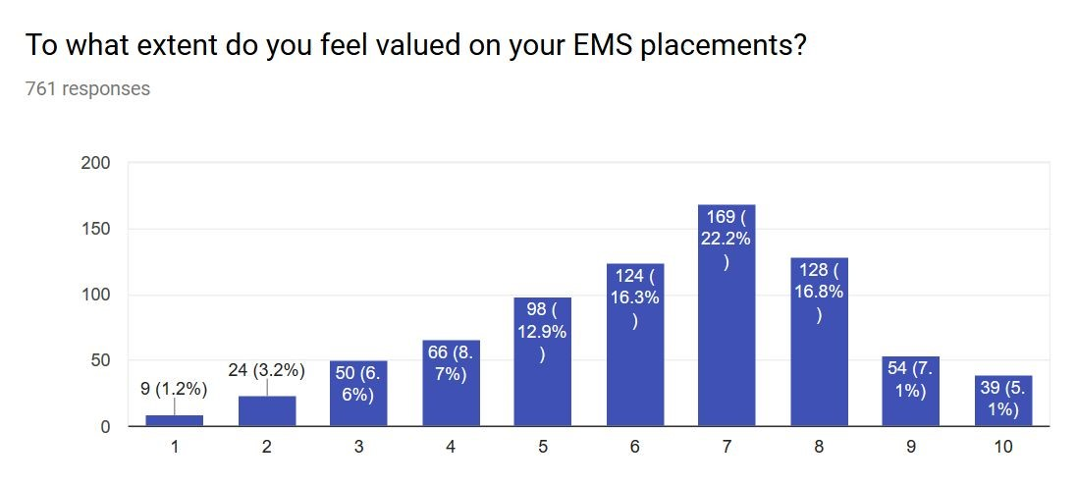
Respondents gave slightly higher scores in response to the question “how satisfied are you with your EMS placements so far”. The modal score was 8/10 with a mean of 6.9/10, although there were few very high scores (fewer than 16% of students selected 9/10 or higher).
Respondents emphasised the variability of placements and difficulty of developing relationships during short placements in the free text section, with one student commenting that:
“… Some practices I would give a 10 for how valued I felt, and some I would give a -10 because I was clearly just annoying them with my presence and normal level of enthusiasm to learn … [in] some practices I was 'over satisfied' with how much I learned and was allowed to do, but on some clinical placements I was ignored, throughout the whole placement, and therefore go to do and learn nothing, despite my confidence in asking questions and trying to strike up conversation/rapport.”

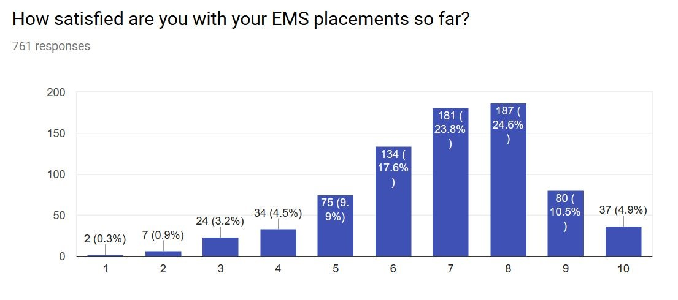
Many respondents noted the difficulty of securing placements at practices with a genuine interest in developing students’ skills, and were concerned about their lack of opportunities compared to other students’ experiences. A number reported feeling like an
“inconvenience” or “burden”. Having these experiences early in a student’s clinical years could shape their perception of the veterinary profession and their personal ability to ‘fit’ within it. This is a particular risk for students who have committed to spending multiple weeks at a Foster Practice, and those without multiple practices to choose from close to their home or university accommodation. Students without multiple placements to compare between, and those without support and professional networks, may feel that they as an individual are the cause of the problem. This is particularly likely if their peers report positive experiences of EMS.
Comments included:
“I really struggled to find a place where I felt comfortable, I have completed weeks and weeks of placements where I felt awful, ignored and resented almost for asking questions. It has made me want to quit my degree more than once.”

“Most practices don't really want to engage with you, they are happy to have you there but mostly to just stand and watch. Enough vets or nurses moan about new grads who take 4 hours to do a dental (for example) but don't want to help students learn so that they are more productive vets. All practices should have to take students and this shouldn't be restricted to a certain uni. Not everyone can afford lots of money for accommodation to stay away from home.”

“Many vets make you feel like you’re in the way and don’t really want to help you. Saying that it’s actually often the nurses who seem to resent you most and they are the people you are usually shoved with. In consults it just feels like you have to hover and watch often in smallies practice. I have found Equine practice to be much more inclusive.”

“The score for practices would range from 2 to 10 for my levels of satisfaction from the placement. It really varies so much and whilst it does have something to do with the student it is mostly practice dependent.”

Pre-clinical students’ expectations of clinical EMS

Respondents
Pre-clinical from all nine vet schools participated in this section of the survey.
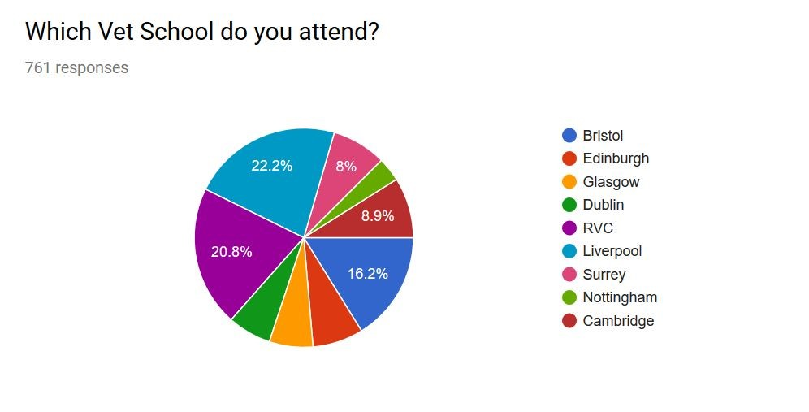
Respondents’ objectives for EMS placements were very similar to clinical students’, including gaining a broad range of experience, practicing clinical skills, having a “hands on” experience and learning the business realities that shape treatment plans.

Concerns about Clinical EMS
59.8% reported concerns over clinical EMS, despite 58.3% having already received clinical EMS guidelines from their university. A number of first year students reported feeling worried about EMS, and universities may therefore want to consider introducing the topic early in the pre-clinical years.
The majority of guidance reported was practical, such as the number of weeks required, dress code and driving licence requirements.

Opinions on why clinical EMS is useful
Respondents frequently commented that clinical EMS provides an opportunity to:
- Gain a hands on, realistic experience which cannot be provided in lectures
- Watch, learn and improve skills in a range of situations, giving more breadth than university scenarios
- Understand the types of environments which vets work in, and which [the respondent] prefers
- Make professional contacts and build relationships with potential employers
- Put theory into practice, broaden knowledge, increase confidence and reduce nerves after graduation.

AVS EMS Experience Survey 2018
AVS are very aware that the experience of students can vary hugely while on clinical EMS. AVS have the opportunity to present to practitioners and publish an article for vets in practice about how they can work to optimise the experience for students they take on EMS.
Students give up a lot of their holiday to undertake their EMS so we're very keen to work with vets to make it beneficial for everyone, standardise it a bit more and encourage practices to get students to do more clinical work and spend less time feeling like a piece of the furniture.
So tell us about your experiences and expectations!
One respondent will win a free AVS Sports Weekend 2018 ticket and one respondent will win a free ticket to London Vet Show in November.
* Required
1. Which Year are you in? * Mark only one oval.
1st Skip to question 27.
2nd Skip to question 27.
3rd Skip to question 17.
Intercalated Year Skip to question 2.
4th Skip to question 17.
5th Skip to question 17.
6th Skip to question 17.
Graduated Vet Skip to question 3.

Students on an Intercalated Year
2. Have you completed any clinical EMS yet? * Mark only one oval.
Yes Skip to question 17.
No Skip to question 27.

Graduated Vets EMS Experiences
- Which Vet School did you attend? * Mark only one oval.
Bristol After the last question in this section, skip to question 34.
Edinburgh After the last question in this section, skip to question 34.
Glasgow After the last question in this section, skip to question 34.
Dublin After the last question in this section, skip to question 34.
RVC After the last question in this section, skip to question 34.
Liverpool After the last question in this section, skip to question 34.
Nottingham After the last question in this section, skip to question 34.
Cambridge After the last question in this section, skip to question 34.
- Which year did you graduate? *

- Do you/have you worked for a practice you did EMS at? * Mark only one oval.
Yes - I work in a practice I did EMS at as a student
Yes - I used to work in a practice I did EMS at as a student
No - But I did receive job offer(s) from places I saw EMS
No - But I did apply to one/some of them
No
- As a graduate vet do you think EMS helped prepare you for practice in ways rotations/practicals at vet school couldn't?

- What makes a 'good' EMS placement? *

- On your EMS, were there any stand out things practices did that helped you get the most from the placement?

- Would it have been useful to be able to chat to the practice on your first day and set objectives for your EMS placements? * Mark only one oval.
Yes
No
Other:
- Do you feel EMS gave you enough practical opportunities? *
e.g placing catheters, blood sampling, intubation, surgery Mark only one oval.
Yes
No
Other:
- Would you have done anything differently on your EMS placements knowing what you know now? *
e.g would you have seen more weeks in certain areas?, would you have prepared more for EMS weeks?
Skip to question 34.

Bristol Foster Practice System
Bristol Vet School are the only vet school to run the 'foster practice' system and we hear from a lot of Bristol students, graduates and practices about the benefits it can offer so we'd love to hear your opinions.
- Do you have a foster practice? * Mark only one oval.
Yes
No
- What would you say are the main benefits (if any) of the foster practice system run at Bristol? *

- Do you get to take more active role at your foster practice than other places you undertake EMS? *
Mark only one oval.
Yes
No
Other:
- If you don't have a foster practice, why not?
If you have a foster practice please leave this question blank

- Any other comments about the foster practice system?
Skip to question 34.

Clinical EMS Experience
- Which Vet School do you attend? * Mark only one oval.
Bristol After the last question in this section, skip to question 12.
Edinburgh After the last question in this section, skip to question 34.
Glasgow After the last question in this section, skip to question 34.
Dublin After the last question in this section, skip to question 34.
RVC After the last question in this section, skip to question 34.
Liverpool After the last question in this section, skip to question 34.
Surrey After the last question in this section, skip to question 34.
Nottingham After the last question in this section, skip to question 34.
Cambridge After the last question in this section, skip to question 34.
- What are your top priorities on an EMS placement? *

- What makes a "good" clinical EMS placement? *

- Can you give examples of any particular things practices have done to improve your EMS experience? *

- Would it have be useful to be able to chat to the practice on your first day and set objectives for your EMS placements? * Mark only one oval.
Yes - and it happens at most places I do EMS
Yes - but it rarely happens
No
- To what extent do you feel valued on your EMS placements? * Mark only one oval.
  - 2 3 4 5 6 7 8 9 10

I don't feel like the practice want me there | The  practice  make me feel like a  member of the team

- How satisfied are you with your EMS placements so far? * Mark only one oval.
  - 2 3 4 5 6 7 8 9 10

I have gained nothing from my EMS that  I haven't learnt at vet school | I am fully satisfied with what I learn/am  allowed to do on EMS

- Any comments related to your satisfaction score?

- What are the main skills you want to learn/perfect during your 26weeks of clinical EMS?
Any other comments?
26
.
Skip to question 34.

Expectations of Clinical EMS
The RCVS says that in order to become a member of the college at graduation you must have completed 26 weeks of clinical EMS amongst other requirements.
- Which Vet School do you attend? * Mark only one oval.
Bristol After the last question in this section, skip to question 34.
Edinburgh After the last question in this section, skip to question 34.
Glasgow After the last question in this section, skip to question 34.
Dublin After the last question in this section, skip to question 34.
RVC After the last question in this section, skip to question 34.
Liverpool After the last question in this section, skip to question 34.
Surrey After the last question in this section, skip to question 34.
Nottingham After the last question in this section, skip to question 34.
Cambridge After the last question in this section, skip to question 34.
- What do you expect to gain from your clinical EMS? *

- Are you nervous or worried about clinical EMS? * Mark only one oval.
Yes
No
Other:
- Have you been given any clinical EMS guidelines by your uni? * Mark only one oval.
Yes
No
Other:
- What advice have you been given by your uni about clinical EMS? *

- Why do you think clinical EMS is useful? *
Any other comments?
33
.
Skip to question 34.

Competition
34. What's your email address?
Please only include this if you would like to be entered into the draw to win a free AVS Sports Weekend or London Vet Show ticket

London Vet Show ticket kindly donated by:

Powered by

https://www.bva.co.uk/uploadedFiles/Content/Membership_and_benefits/BVA-AVS-Research-Report-2016.p df
​http://www.avsukireland.co.uk/recent-news/3/5/2018/rc9ht6oyitgt88a0tr2254jmhn86oe​; https://veterinaryrecord.bmj.com/content/182/25/ii
https://www.londonvetshow.co.uk/business-theatre/ems-making-it-work-for-students-and-practices--with-ex clusive-results-from-the-avs-ems-experience-survey​; ​https://www.londonvetshow.co.uk/for-students
​https://www.rcvs.org.uk/lifelong-learning/students/veterinary-students/extra-mural-studies-ems/ https://www.rcvs.org.uk/document-library/report-of-ems-survey-201314/
​https://www.rvc.ac.uk/News/PressReleases/pr0912_EMSpreptool.cfm​; http://www.ems.vet.ed.ac.uk/emsdl/

