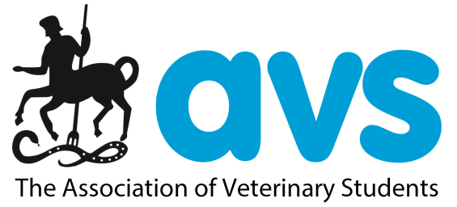
AVS/IVSA UK & Ireland Elections 2019
avscommittee@gmail.com /AVS.UK.Ireland AVS_UK_Ireland

Name:
Position:
Vet School:
Year:
About me:

Experience:

What I would try to achieve in my role:

Why you should vote for me:

